Property Listings

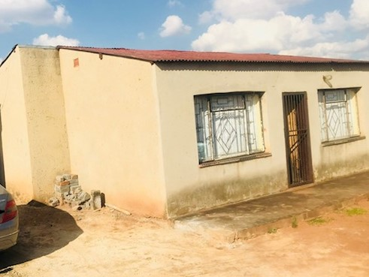

Motsamai Section, Katlehong R510K

- 2 bedrooms

-bathroom

-Lounge

-Dining room

-Kitchen

-Garage

- 2 outside rooms

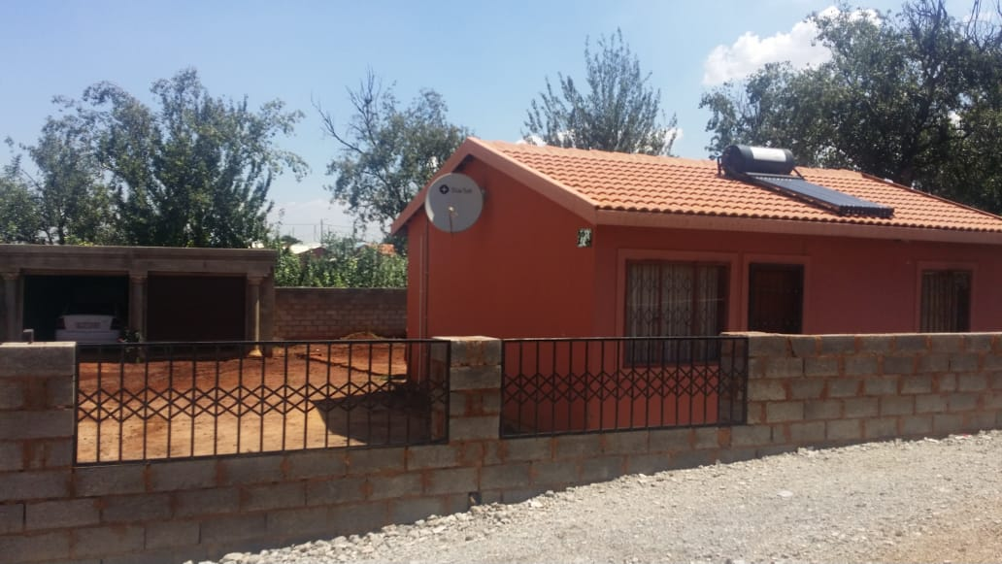

Villa Liza R420k

* 2 Bedrooms
* Bathroom
* Lounge
* Kitchen
* Double Garage
* Big yard

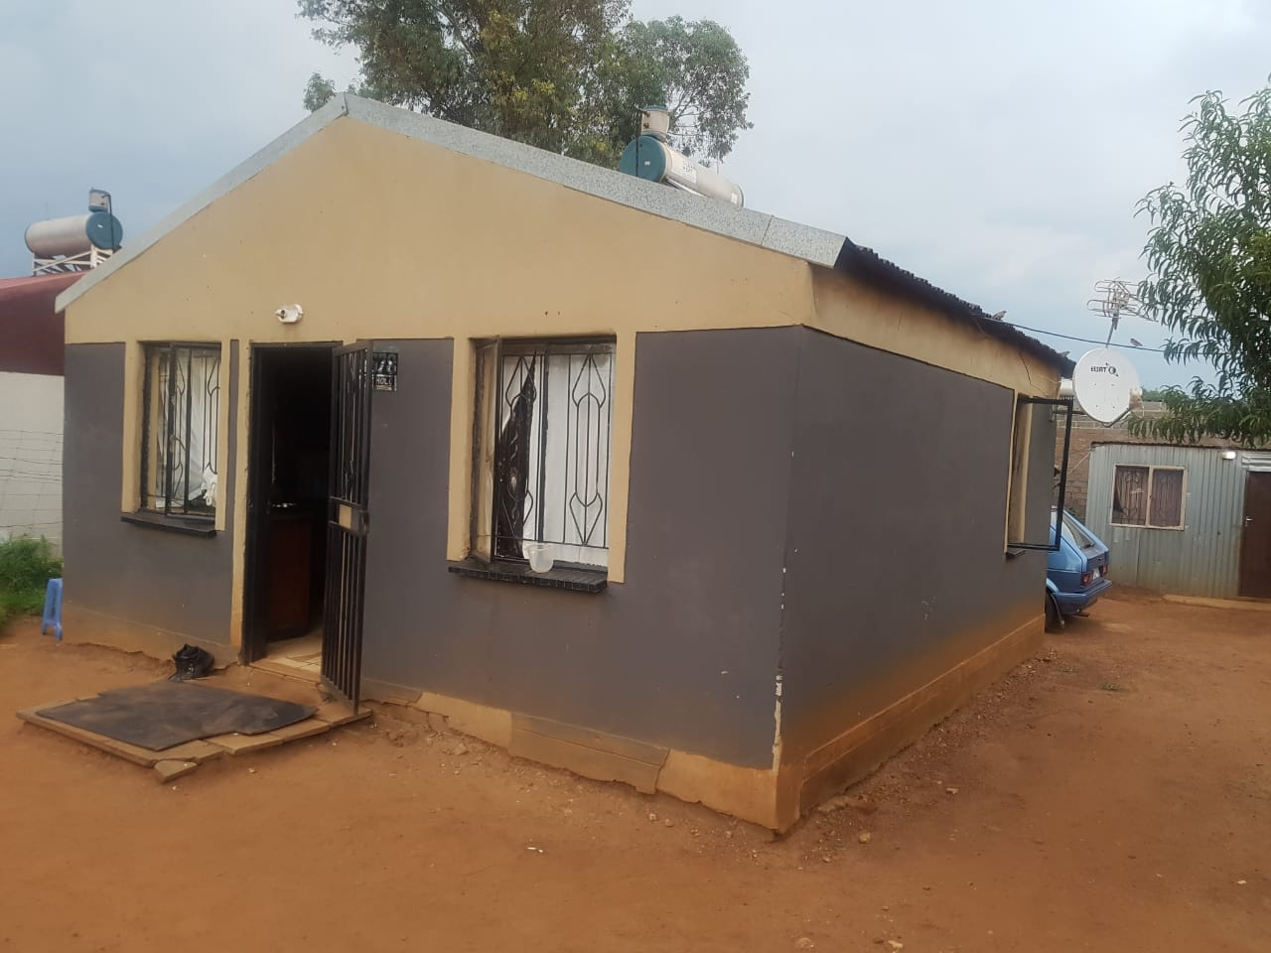

Greenfields R250k

* 1 Bedroom
* Kitchen
* 1 Bathroom

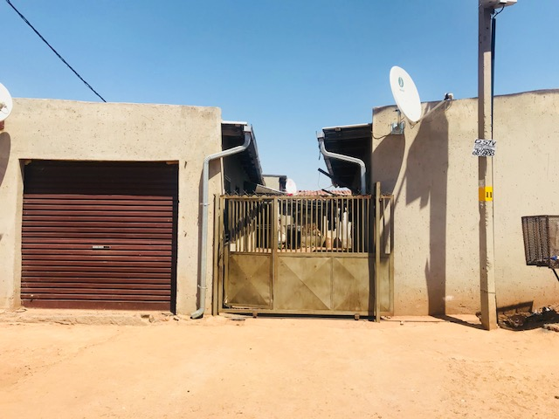

Rondebult R400k

* 1 Bedroom
* Kitchen
* 8 Outside rooms

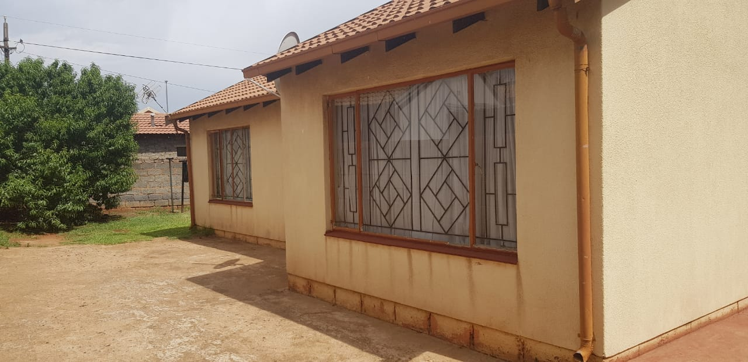

Ext 8 Vosloorus R650k

* 3 bedrooms
* Dining room
* Lounge
* Kitchen
* Bathroom with separate toilet
* Walled

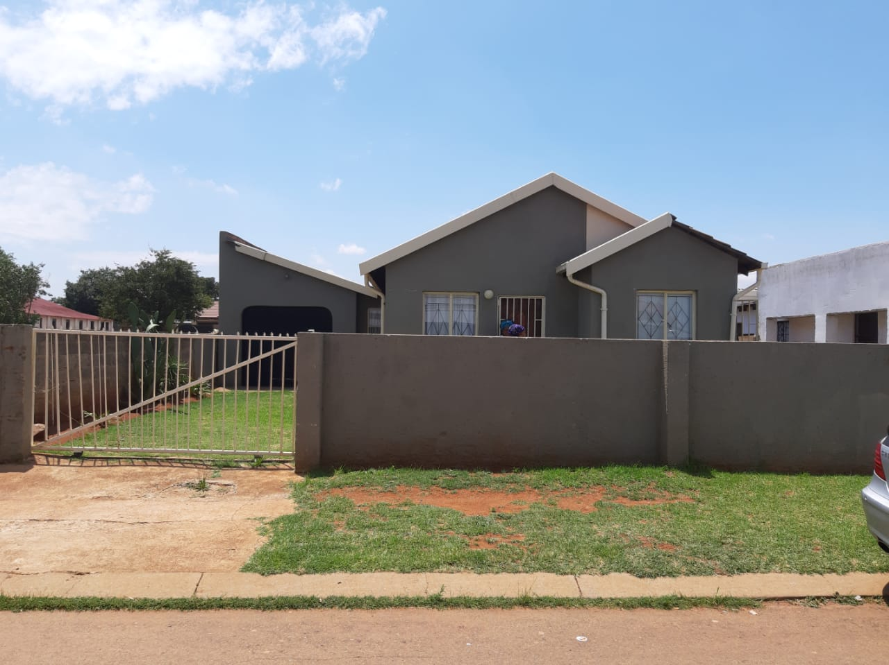

Ext 7 Vosloorus R630k (OFFER PENDING)

* 2 Bedrooms
* Bathroom
* Dining room
* Fitted Kitchen
* Garage
* 1 Outside room

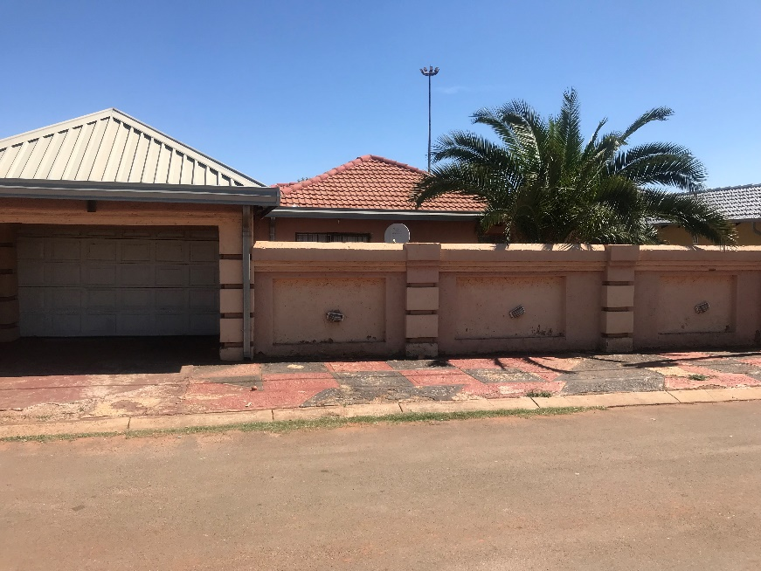

Ext 6 Vosloorus R730k (OFFER PENDING)

* 3 bedrooms
* 2 bathrooms
* dining room
* lounge
* Kitchen
* Big carport

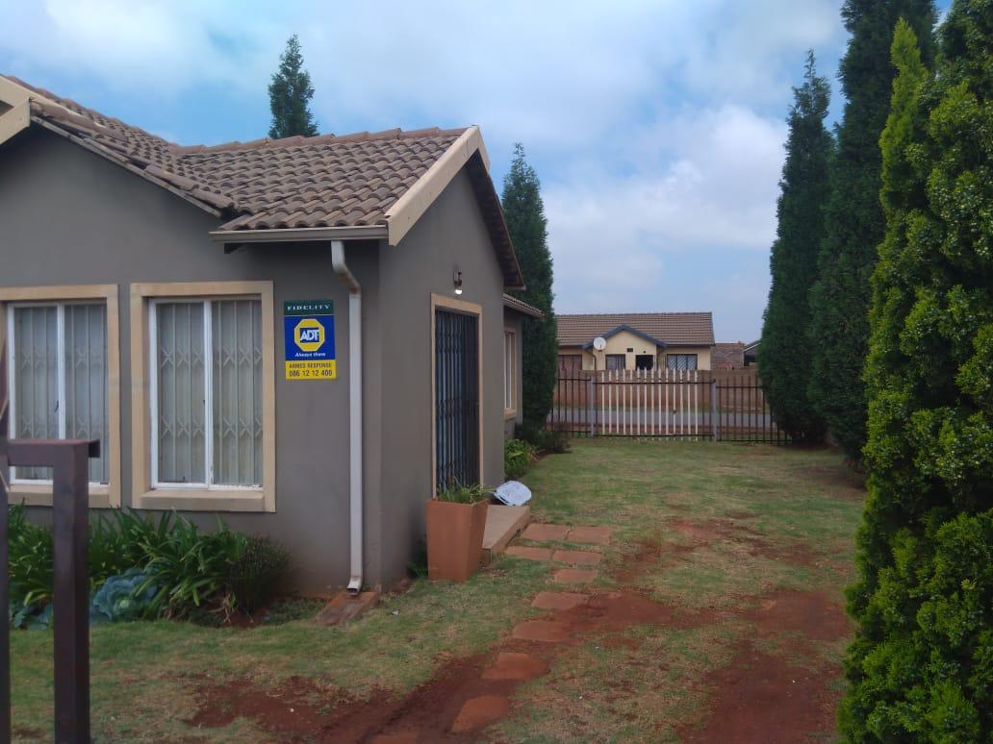

Dawn Park R760K

* -3 bedrooms
* -2 bathrooms
* -Kitchen
* -Lounge

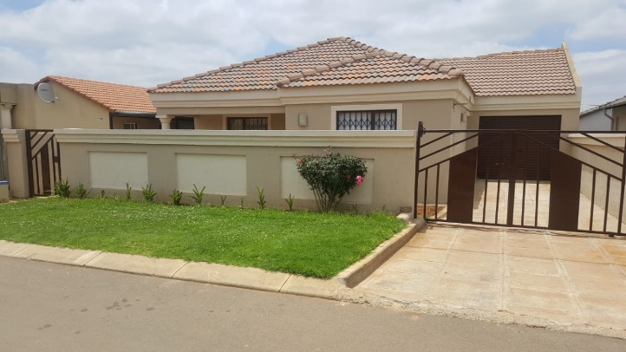

Windmill Park R750k

* 3 bedrooms
* 2 bathrooms
* Kitchen
* Dining room
* Lounge
* Garage
* 1 outside room

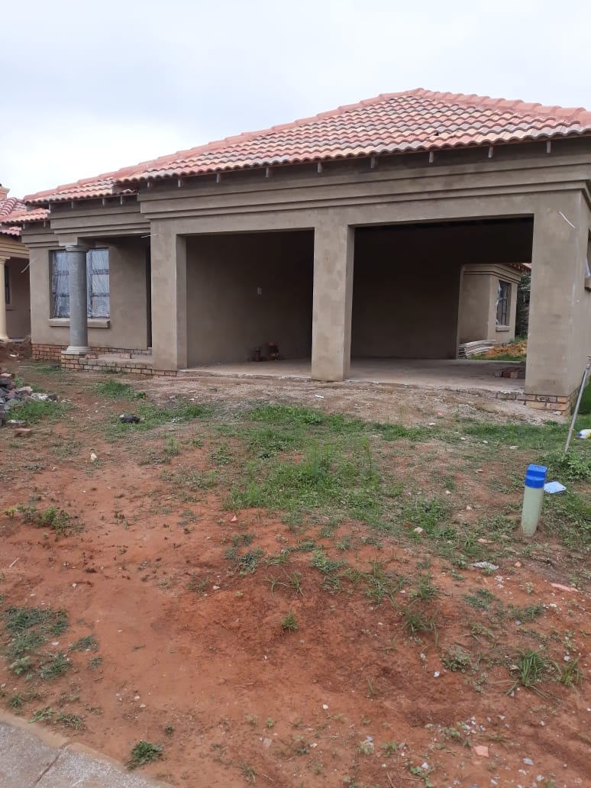

Oakland Estate, Brakpan R920K

* 3 bedrooms
* 2 bathrooms
* dining room
* Lounge
* Kitchen
* Double garage

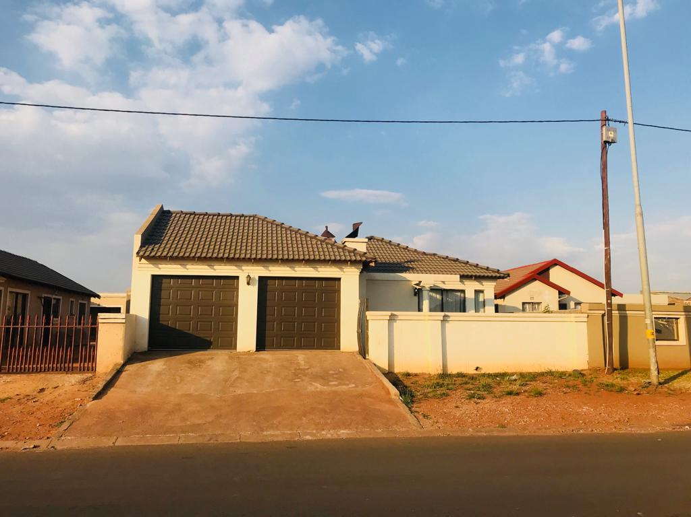

Ext 6, Vosloorus R730K

* -3 bedrooms
* -2 bathrooms
* -Lounge
* -Dining room
* -Kitchen
* -Double garage
* Big yard

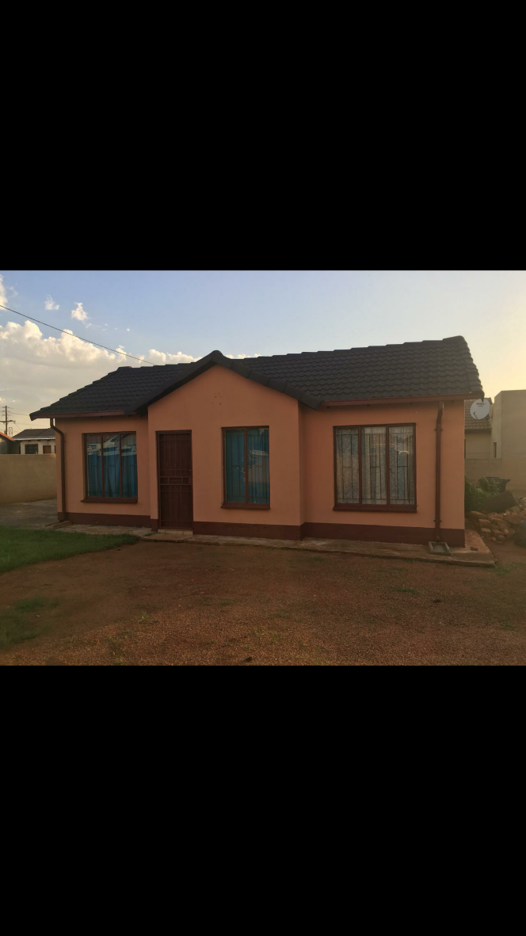

Ext 31 Vosloorus R680k

* 3 bedrooms
* Bathroom
* Dining room
* Fitted kitchen
* Very big yard

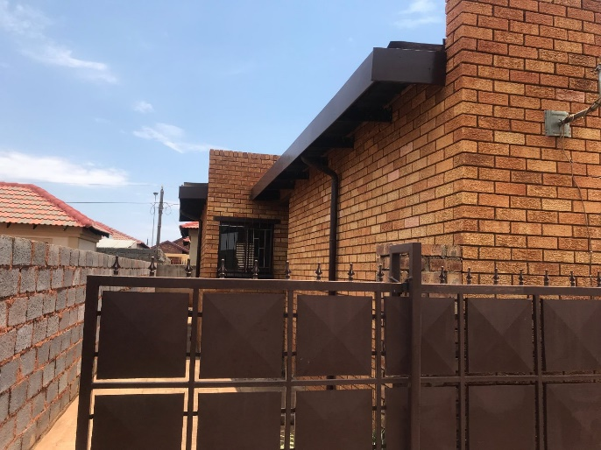

Siluma View R600k (OFFER PENDING)

* 3 Bedrooms
* 2 Bathrooms
* Dining room
* Lounge
* Kitchen
* Garage

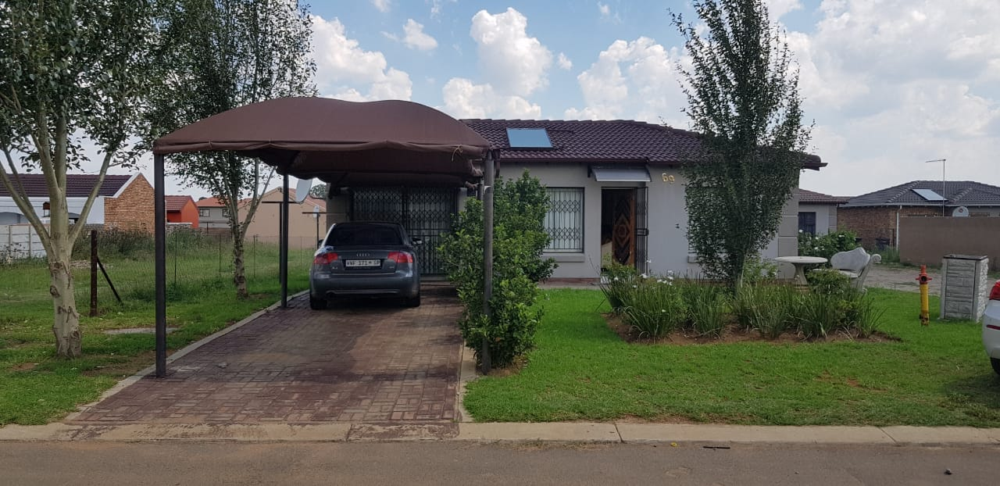

Sharon Park Estate R780K

* 3 Bedrooms
* 2 Bathrooms
* Kitchen
* Dining room
* Lounge
* Carport
* Secured complex with 24 hours security

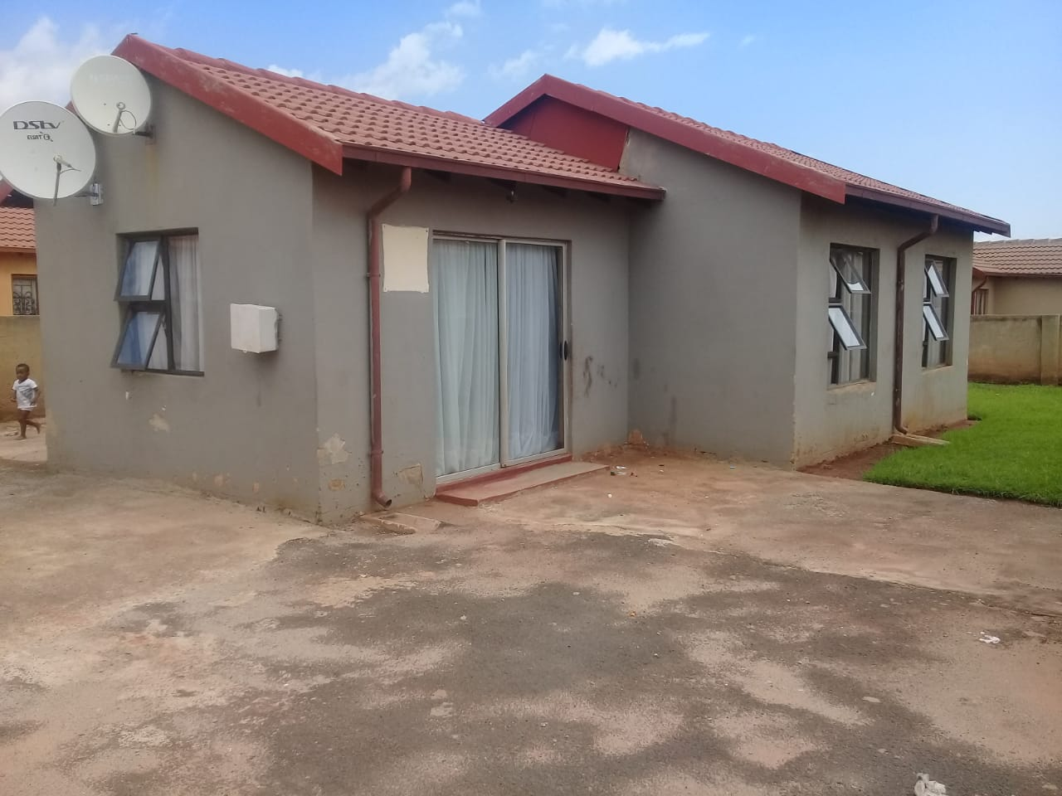

Ext 6 Vosloorus R680k

* 3 Bedrooms
* 2 Bathrooms
* Lounge
* Fitted Kitchen
* Big Yard
* Walled

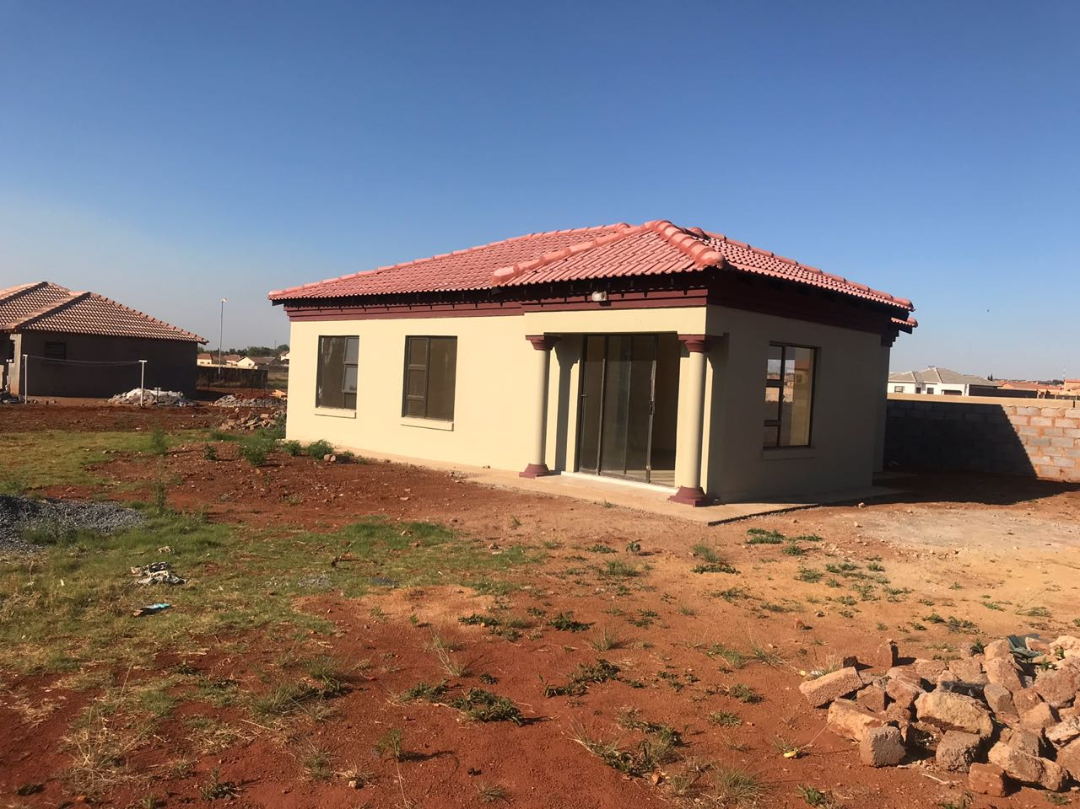

Dawn Park R980k

* 3 Bedrooms
* 2 Bathrooms
* Lounge
* Open plan kitchen
* Big Yard

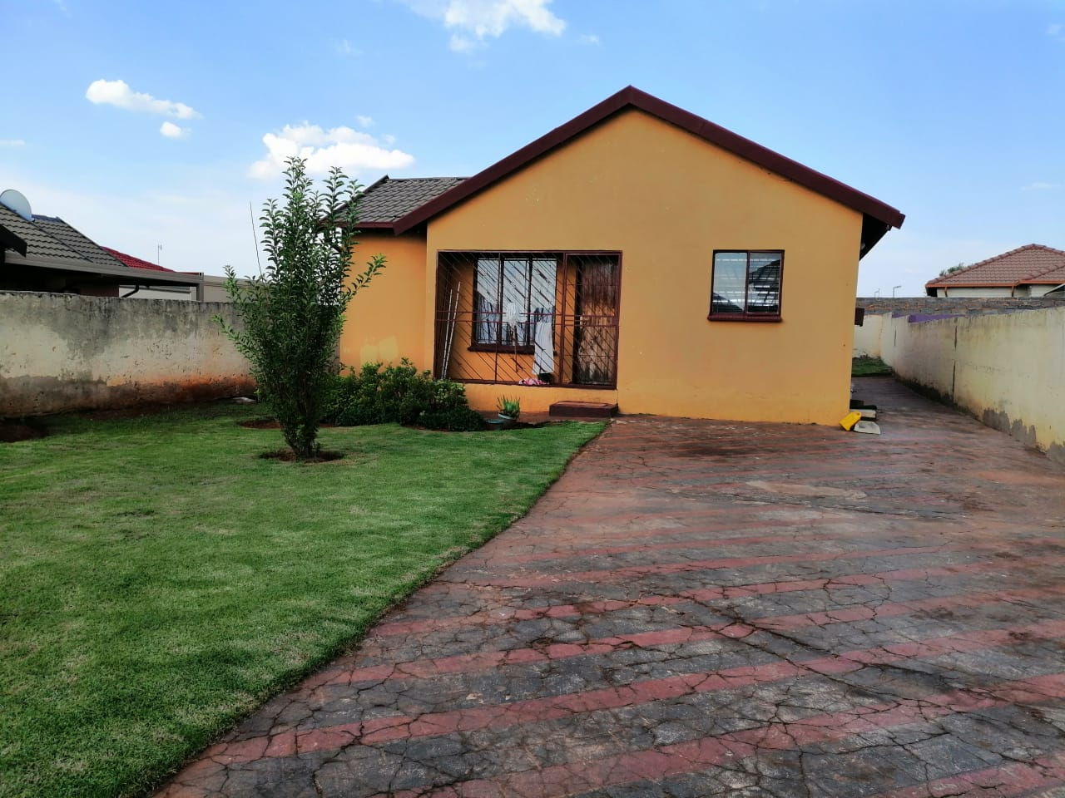

Dawn Park R690k

* 3 Bedrooms
* 2 Bathrooms
* Lounge
* Kitchen
* Walled
* Big yard

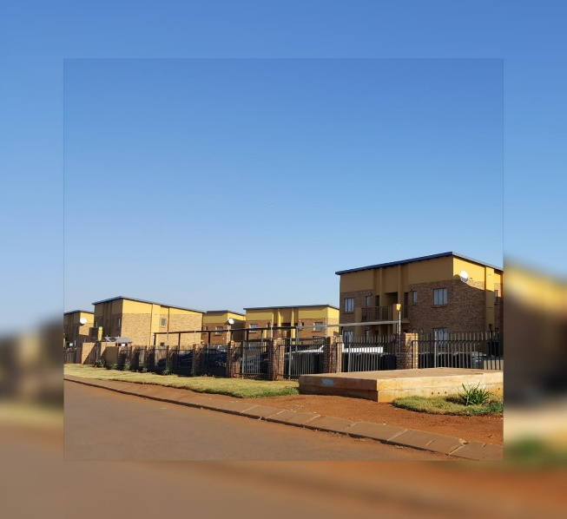

Jezzyberry R430k

2 Bedooms

* 2 Bathrooms
* Kitchen
* Lounge

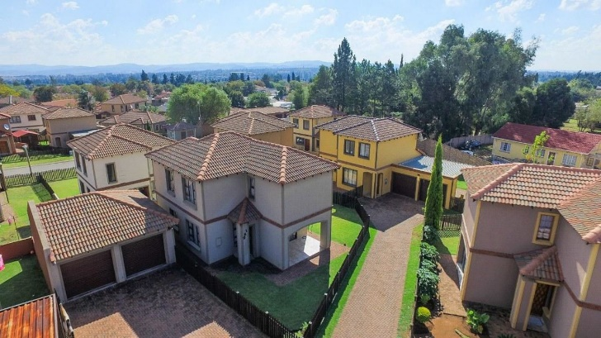

Meyersig R1.3mil

* 3 Bedrooms
* 2 Bathrooms
* Kitchen
* Lounge
* Double garage
* Free standing house in a secure complex

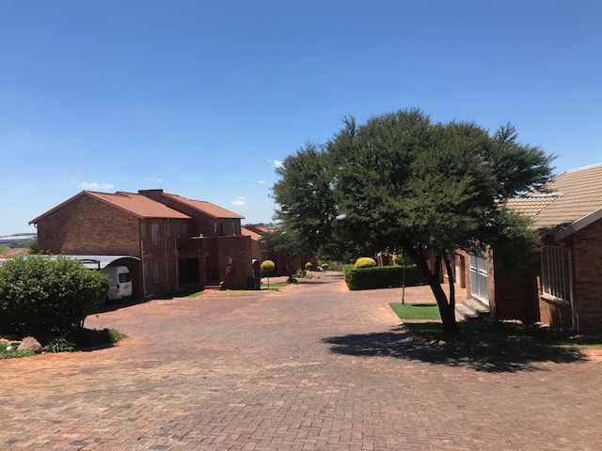

Elands Rock Estate, Alberton R880k

* 3 Bedrooms
* 2 Bathroom
* Kitchen
* Lounge
* Double Carport
* Secure Estate

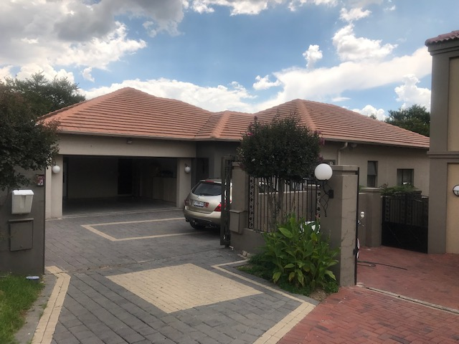

Bushwillow Park Estate R3.6mil

* 5 Bedrooms
* 3 Bathrooms
* 2 Lounge
* 2 Dining room
* Kitchen
* Scullery
* Entertainment room
* Flatlet
* Office
* Double Garage

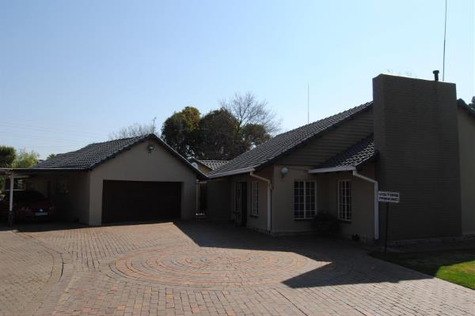

Morning Hill R2 950 000

* 4 Bedrooms
* 3 Bedrooms
* Dining room
* Lounge
* Kitchen
* Entertainment room/Bar & Braai room
* Store room
* Pool
* Double Garage
* Carpot for 8 cars
* Cottage with a kitchen
* Nanny’s flat
* Gardner’s room

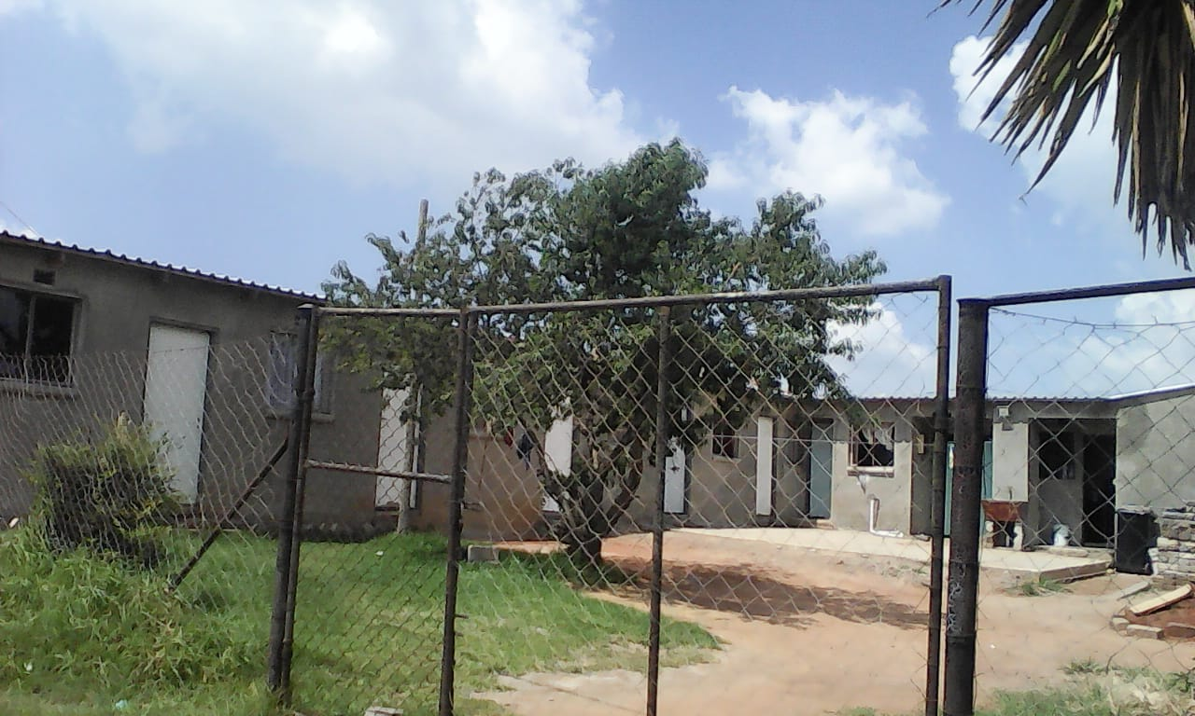

Tsakane R400k (negotiable)

* 5 outside rooms (2 with kitchens)
* 2 toilets

**OFFICE SPACE FOR SALE**

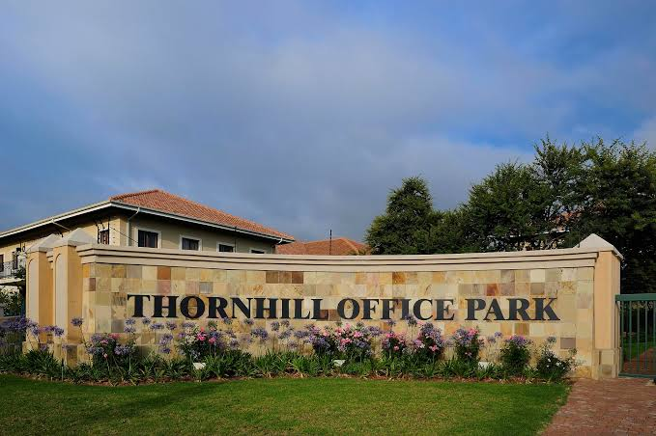

Thornhill Office Park, Vorna Valley Midrand R1.5mil

* 4 Offices
* 1 Boardroom
* Separate Ladies & Gents bathroom
* Kitchen
* 3 Basement parking
* 1 Open bay parking
* 89.2m2

**VACANT LAND FOR SALE**

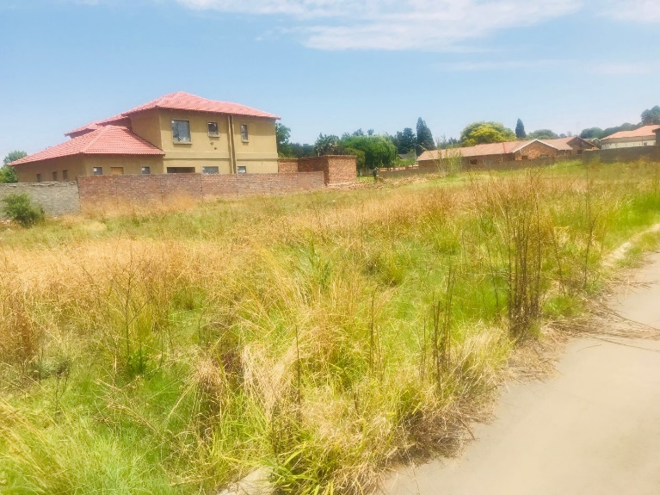

Lambton Gardens R490k

Vacant residential land for sale, size: 500m2



Zuurfontein Farm, Vaal R13million

Vacant land for residential development for sale, size 17 Hectars.

VOSLOORUS BRANCH

21749/164 Nombhela Drive

Ext 6, Vosloorus

1475

Office number: 011 863 5004

Office email: [fikilunga@gmail.com](mailto:fikilunga@gmail.com)

GROENEWEIDE BRANCH

54 Tunny Street

Groeneweide,Boksburg

1459

Office number: 011 916 0135

Office email: fikilunga@gmail.com